Table of Contents

Detail shelf 2

Shelves at Rows and columns 2

Detail Shelf (or Detail Button) 4

Parameters 6

Parameters Overview 6

Define Parameter 6

Filtering 10

Using parameters 10

Filter string values 13

# Lab 0 Jumping into the Deep

# Detail shelf

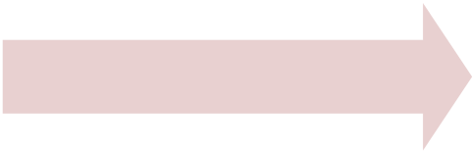

Detail Shelf



Parameters

Filtering

## Shelves at Rows and columns

At our Laboratory, we will use **the SSIPUF.xls data file**.

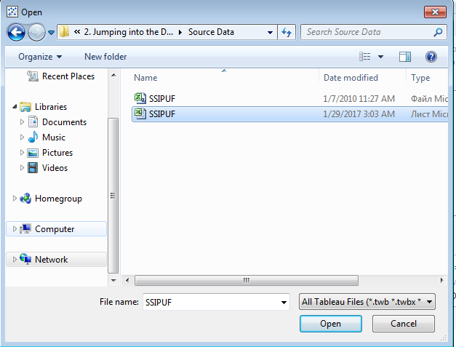

Level of detail (**LOD**) is a feature that was introduced in Tableau Desktop v9. While it offers a great amount of flexibility and control over how you use the data in your visualization, it can be a bit tricky to fully understand.

It’s no matter where we have a grouped value at Rows or at Column, result of usage will be the same.



Detail Shelf



Parameters

Filtering

At our **Sheet1** at **Dimensions** area, we should group **SEX** and **STAT** fields. It can be simply done by the **Ctrl + Click** on one of them and **drop** overthenext.

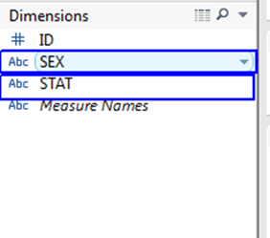

Enter name of our group and press OK.

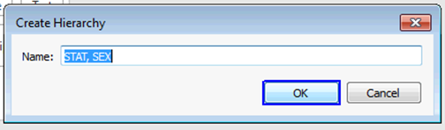

At our example, we need to use our newly created group from **Dimensions** and at last one **Measure** calculated field.

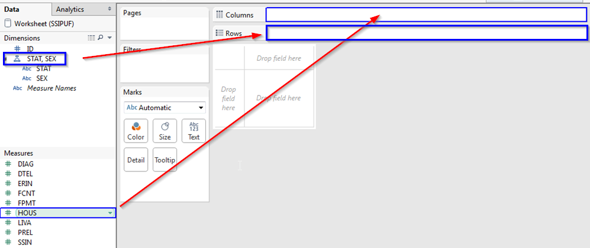

The sequence doesn't matter.

**Tableau** will use a first Dimension field from a group and provide possibility with **+/-** to use all hidden members from a group. Here you can see the difference between the output at the main worksheet area:



Detail Shelf



Parameters

Filtering

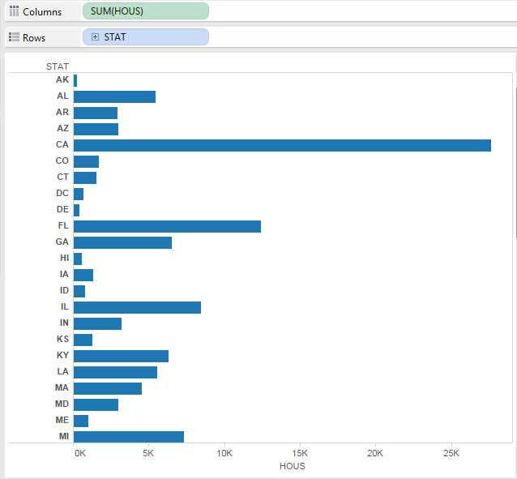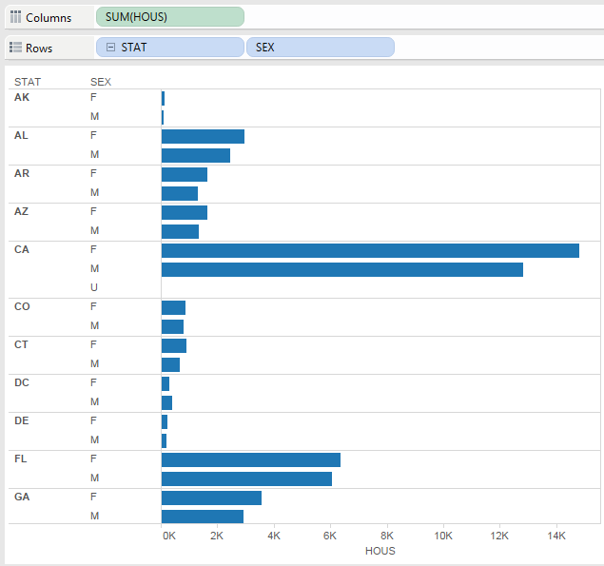

## Detail Shelf (or Detail Button)

The other spot in Tableau Desktop to determine the level of detail is the Detail shelf on the Marks card. This is also commonly referred to as the Detail button. Dragging dimensions onto the Detail shelf will affect your visualization in different ways, depending on your chart type.

Clear our worksheet and use two **Measures** calculated fields.

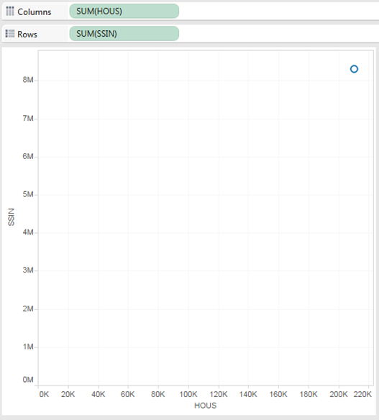

Currently, there is only a single mark on our scatter plot because we are not currently segmenting these measures on any dimensions or disaggregating the results. In other words, our level of detail is at our highest or most aggregated. Let’s add granularity by dragging **Stat** in the Detail shelf:



Detail Shelf



Parameters

Filtering

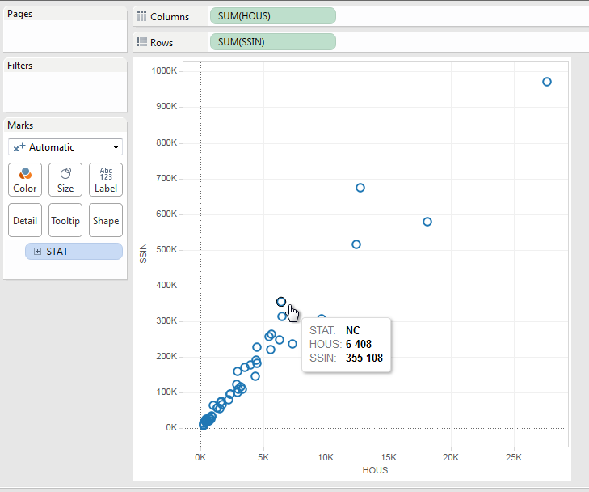

We now have marks for every individual **State**, making this visualization less aggregated and more granular. Adding color or changing the mark shape will obviously make this scatter plot easier to read.

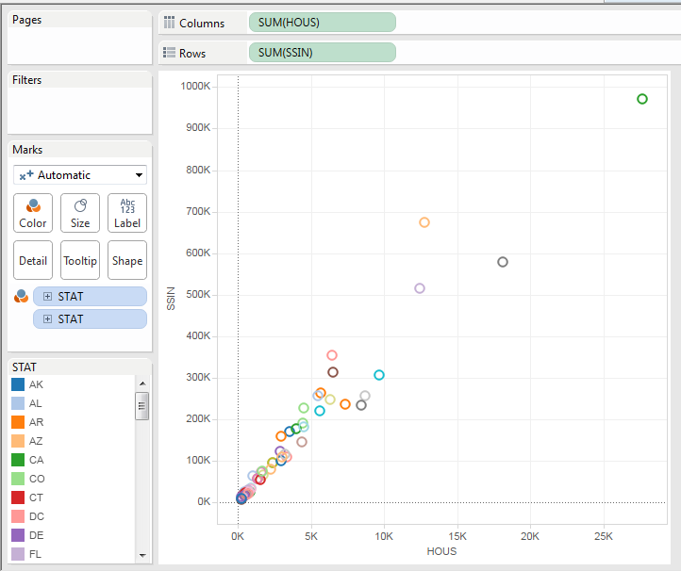

# Parameters



Detail Shelf



Parameters

Filtering



## Parameters Overview

Parameter controls are interactive and allow the report consumer to affect your visualization. Secondly, all the values within your parameter must have a consistent data type. For instance, if one of your values is a string, then they all need to be of the string data type.

Next, the parameters are static. You can populate the list or range of values within a parameter by using a field from your data source, but it will not update the values even if your field values change in your data source. It will be static for the moment the parameter is created.

Parameter values can be:

1. Defined by the Desktop user
2. Entered as an input by the report consumer
3. Populated with the values of a field from the data source

Dynamic parameters are on the list of things Tableau is considering for future versions, but as of 9.3 we are not there yet. Next, the parameters are data source agnostic. This is important when we talk about filtering across views using different data sources on the same dashboard.

Finally, you can use parameters in your custom SQL. This can significantly impact the performance of your worksheets.

## Define Parameter

To define new parameter, follow the next steps:

1. Drag and Drop the **Stat Dimensions** field into **Rows** area.
2. Drag and Drop the **HOUS** field into **the Data area** at working sheet.
3. **Right click** on empty space below the fields of **Measures** area.
4. **Click on** “**Create parameter…”** menu option.



Detail Shelf



Parameters

Filtering



1. Now let consider, how it will look in the program during performing the steps:Drag and Drop **Stat Dimensions** field into **Rows** area.

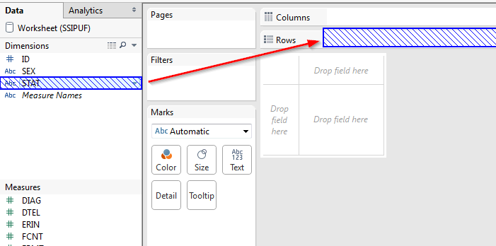

1. Drag and Drop **HOUS** field into **the Data area** at working sheet.

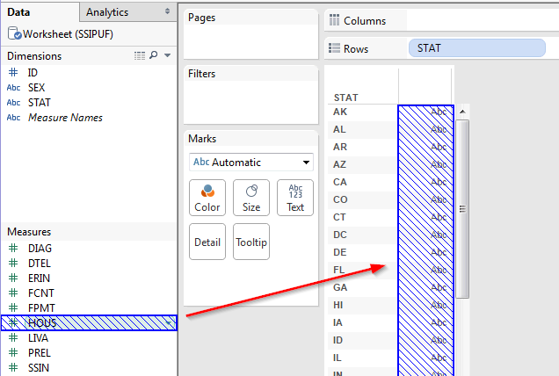



Detail Shelf



Parameters

Filtering



1. **Right click** on empty space below the fields of **Measures** area.

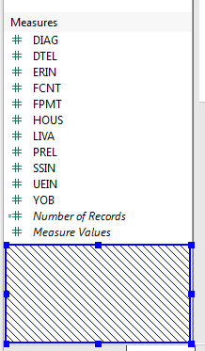

1. **Click on** “**Create parameter…”** menu option.

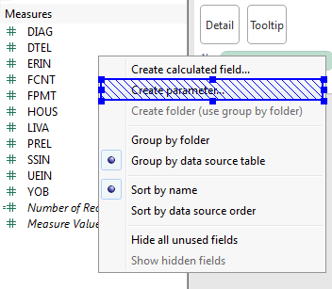

Now we will see more deeply in definition parameter window:



Detail Shelf



Parameters

Filtering



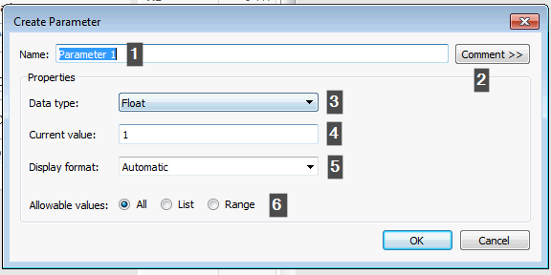

1. Field for defining name of Parameter.
2. An additional window with the possibility to add formatted text which will be used like a tool tip for our parameter.
3. Data type for our parameter. It can be one of the next: **Float, Integer, String, Boolean, Date, Date & Time.** For **Boolean**, you can change the aliases for these values.
4. Value of Parameter – **can be null,** if the selected **type allows** it.
5. You can format your parameter to display any of the standard formatting types, i.e. Standard Currency, Scientific, etc. when appropriate for the data type. I recommend mirroring the display format that is present in your view.
6. Value range for Parameter, here we can select:
   1. **All** to provide the possibility to enter any value into the parameter
   2. **The List** option provides the possibility to select only from a predefined list, which can be imported from some field.
   3. **Range** to provide the possibility to select only from a numeric range of values, here we provide **minimum** and **maximum** values.
   4. These options are not available for **Boolean** naturally.

For our Parameter select:

1. Data type – Integer.
2. Current value – 1.
3. Display format – Currency (Standard) – English (United States)
4. Allowable values – All.

# Filtering

## Using parameters



Detail Shelf



Parameters

Filtering



* **Drag** and **Drop** **STAT Dimensions** field in the **Filter** area.
* Open **Top** tab.
* Change filter type in the **By field.**
* Select **Top, HOUS, Sum.**
* Click on drop down list with an integer value for counting of select.

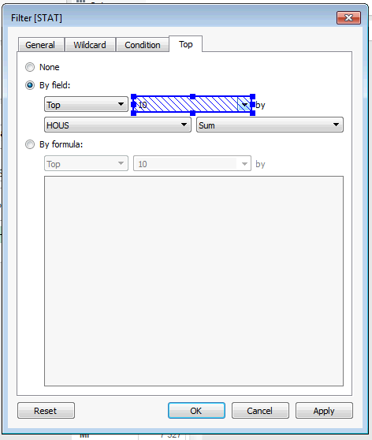

* From a list select “**Create a new parameter…”.**



Detail Shelf



Parameters

Filtering



* New Parameter should be with:
  + Data type **Integer**
  + Current value **10**
  + Allowable values **Range**
  + **Minimum 1**
  + **Maximum 51** – equal to count of rows at main worksheet.

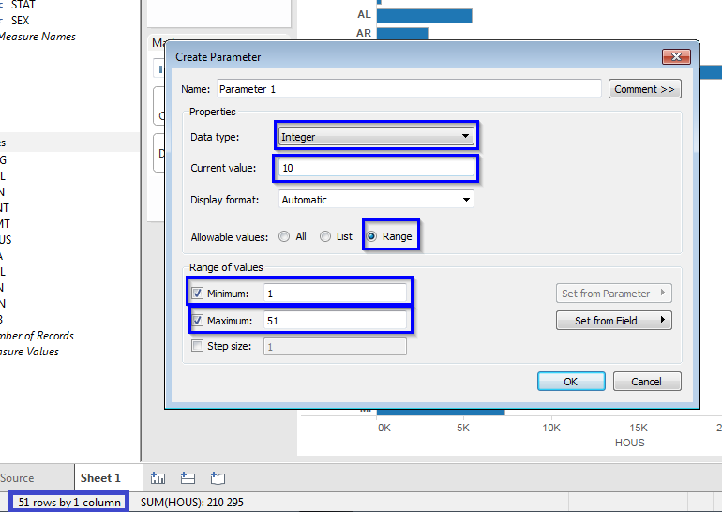

* Apply changes into **Filter [STAT]**
* Click on **OK.**

Now you can modify the Parameter value via typing the value from a range or use a slider:

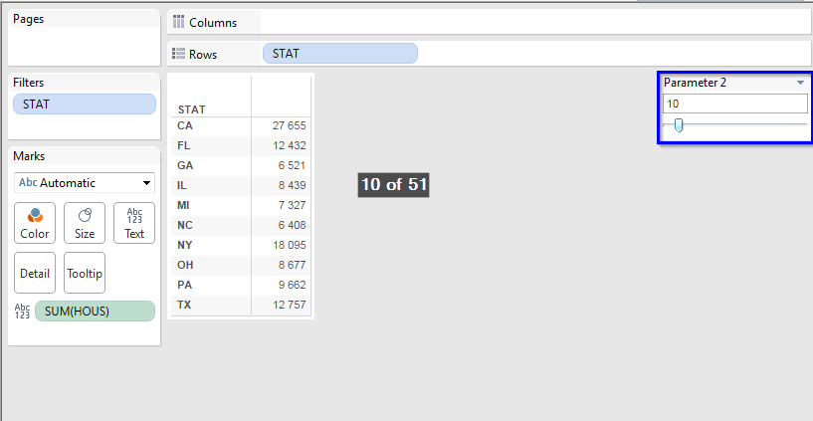



Detail Shelf



Parameters

Filtering



Also, if you need you can set a maximum value from one of **Measures** fields:

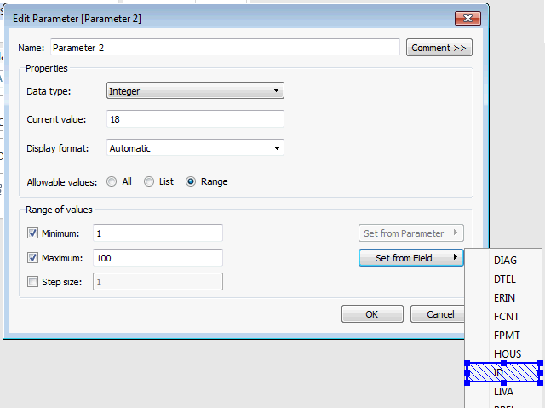



Detail Shelf



Parameters

Filtering



## Filter string values

* Clear main worksheet area.
* Create new Parameter – **Parameter 3**.
* Set Data type – **String**
* Allowable values – **List.**
* Press button **Add from Field.** And select **STAT Dimension** field.

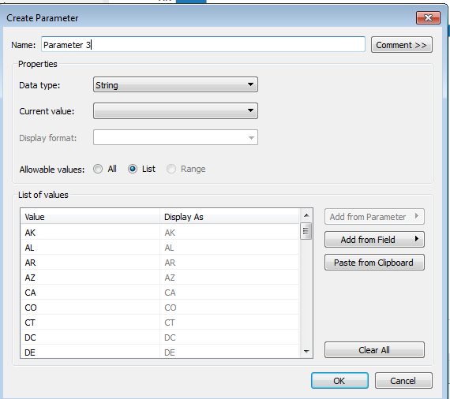

* Drag and drop **Dimension** field **STAT** in the **Rows** area.
* Drag and drop **Measures** field **HOUS** in the **Data** area.
* Open context menu on **Parameter 3** and click on Show parameter control.



Detail Shelf



Parameters

Filtering



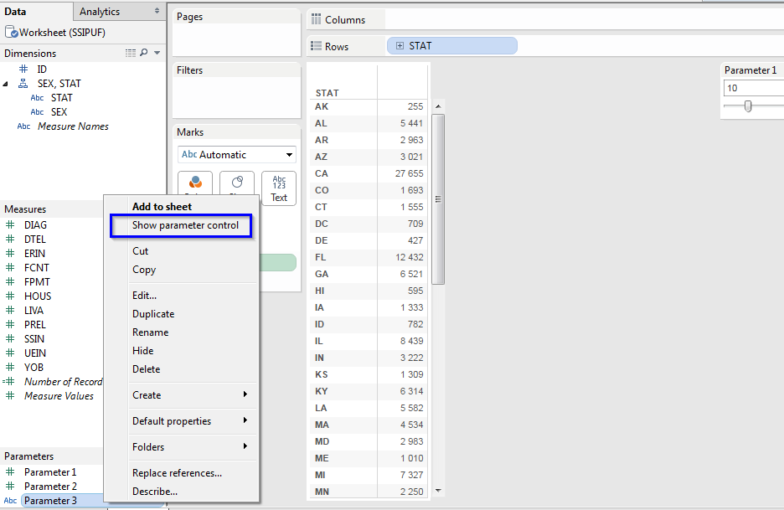

* Drag and drop **Dimension** field **STAT** in the **Filter** area.
* At opened filter definition, click on **Condition** tab.
* Change type to **By formula.**
* Enter condition that **STAT should be equal to Parameter 3.**

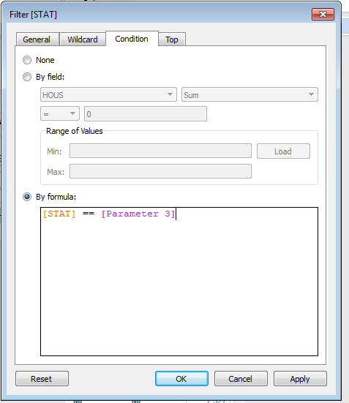

* **Apply** changes and press **OK.**



Detail Shelf



Parameters

Filtering



Now, after changing the **Parameter 3** on working sheet. The Worksheet will change a value right after **Parameter 3** willbe changed.

